**[D]** **Attempt the following:-**

1. 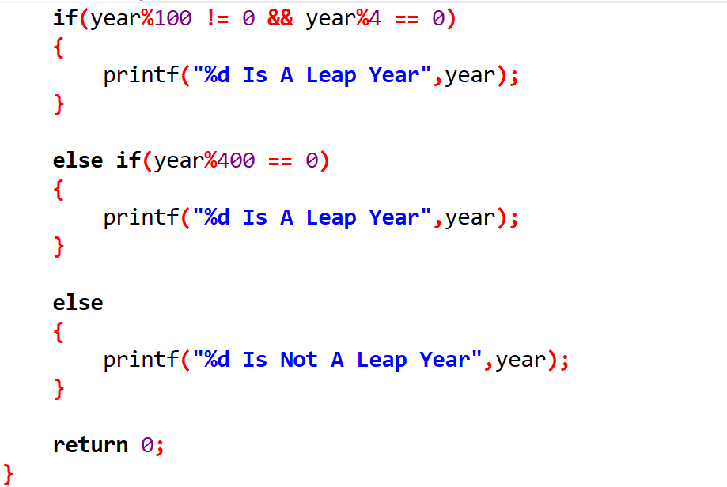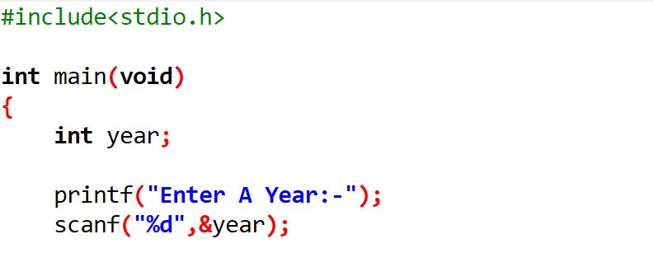Any year is entered through the keyboard, write a program to determine whether the year is leap or not. Use the logical operators && and ||.
2. A certain grade of steel is graded according to the following conditions:-
3. Hardness must be greater than 50
4. Carbon content must be less than 0.7
5. Tensile strength must be greater than 5600

The grades are as follows:-

1. Grade is 10 if all three conditions are met.
2. Grade is 9 if conditions (i) and (ii) are met.
3. Grade is 8 if conditions (ii) and (iii) are met.
4. Grade is 7 if conditions (i) and (iii) are met.
5. Grade is 6 if only one condition is met.
6. Grade is 5 if none of the conditions are met.

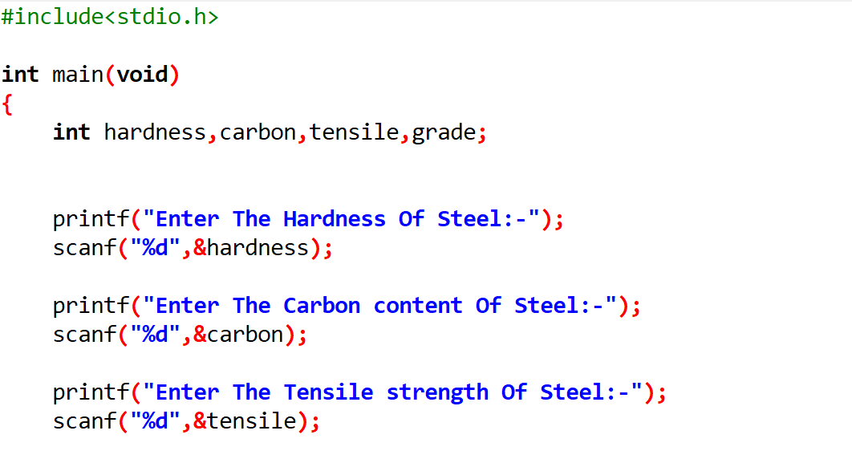Write a program, which will require the user to give values of hardness, carbon content and tensile strength of the steel under consideration and output the grade of the steel

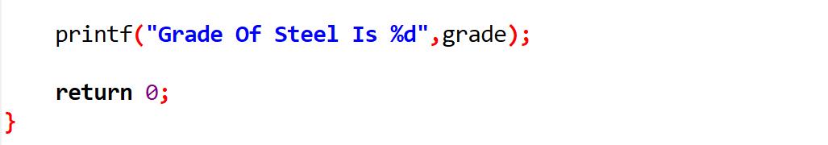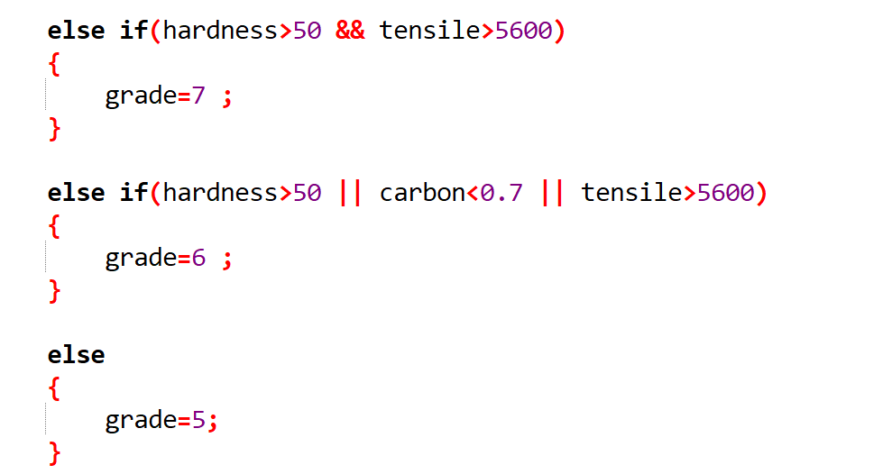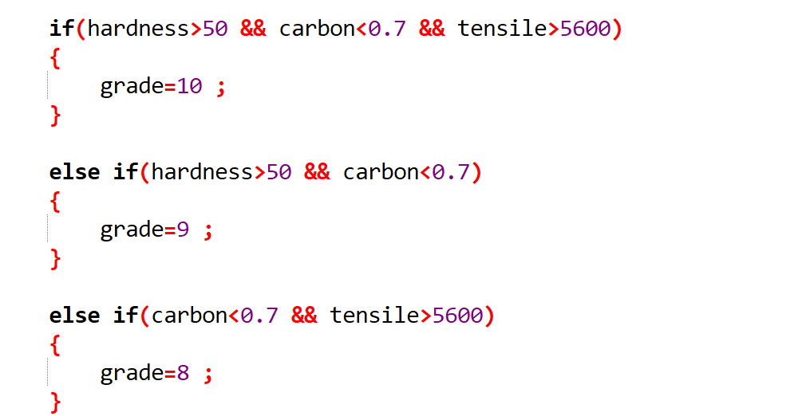

1. If the three sides of a triangle are entered through the keyboard, write a program to check whether the triangle is valid or not. The triangle is valid if the sum of two sides is greater than the largest of the three sides.

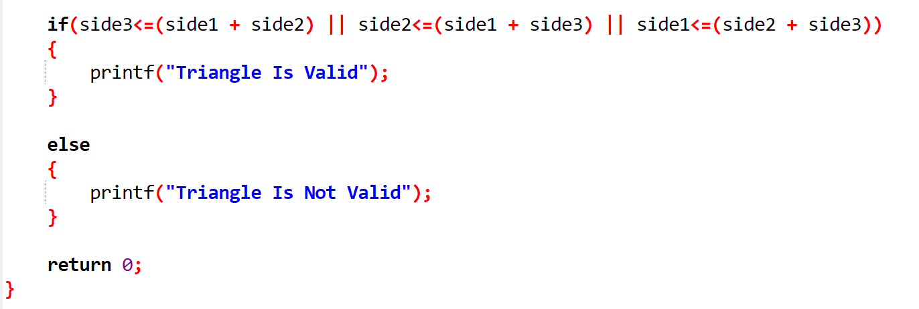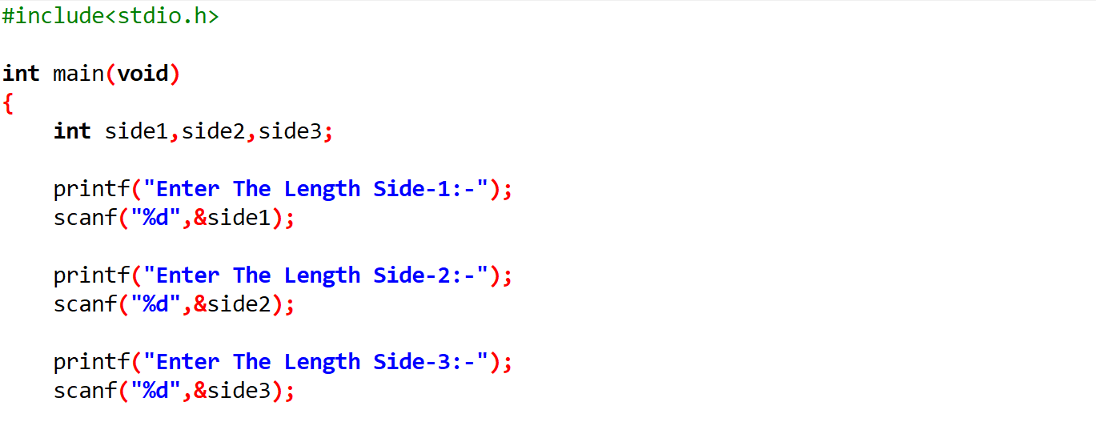

1. 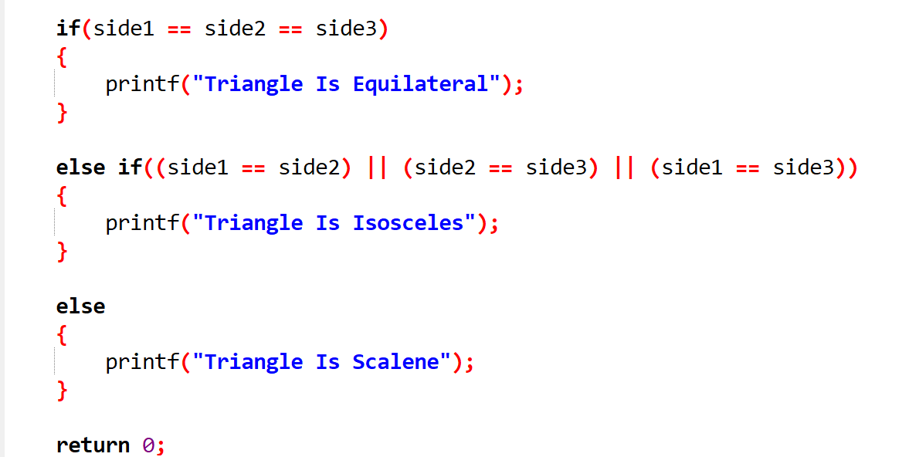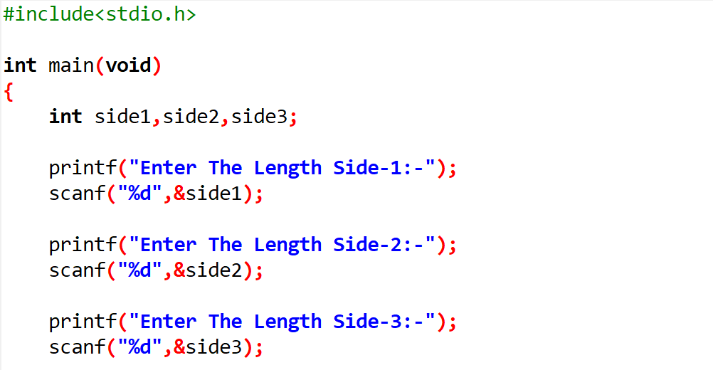If the three sides of a triangle are entered through the keyboard, write a program to check whether the triangle is isosceles, equilateral, scalene or right angled triangle.
2. In boxing the weight class of a boxer is decided as per the following table. Write a program that receives weight as input and prints out the boxer’s weight class.

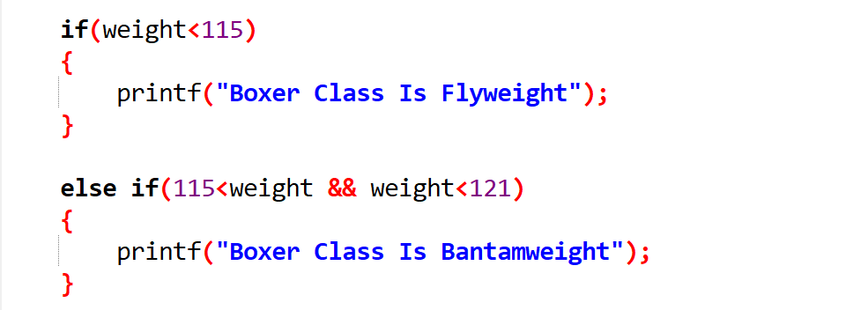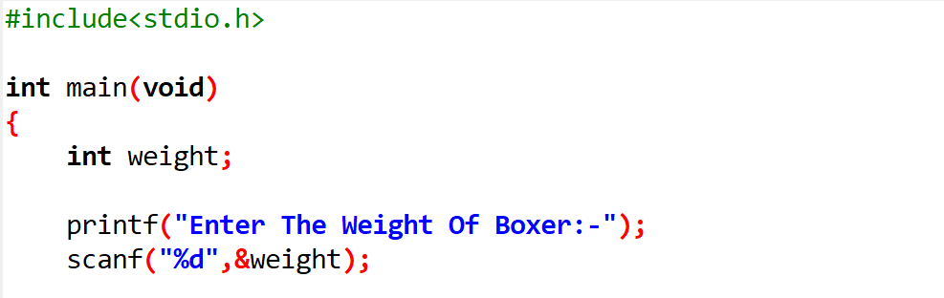

|  |  |
| --- | --- |
| Boxer Class | Weight in Pounds |
| Flyweight | < 115 |
| Bantamweight | 115 - 121 |
| Featherweight | 122 - 153 |
| Middleweight | 154 – 189 |
| Heavyweight | >= 190 |

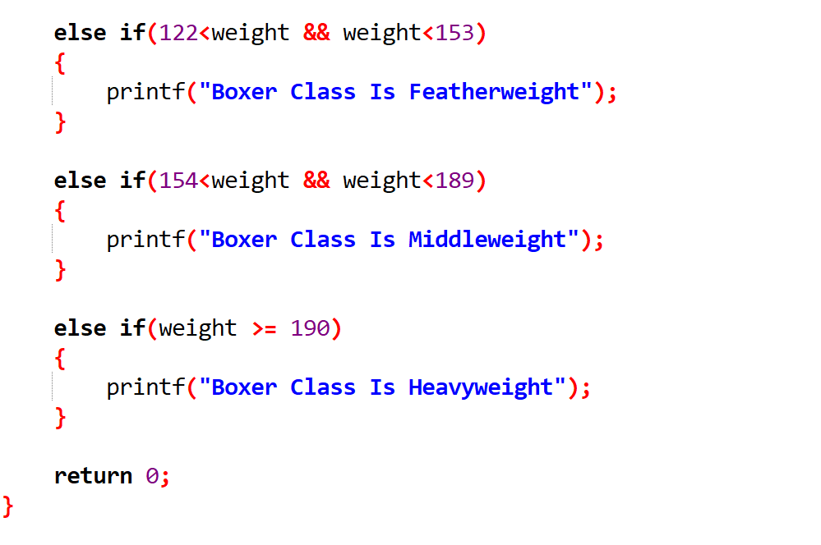

1. The Body Mass Index (BMI) is defined as ratio of the weight of a person (in kilograms) to the square of the height (in meters). Write a program that receives weight and height, calculates the BMI, and reports the BMI category as per the following table:-

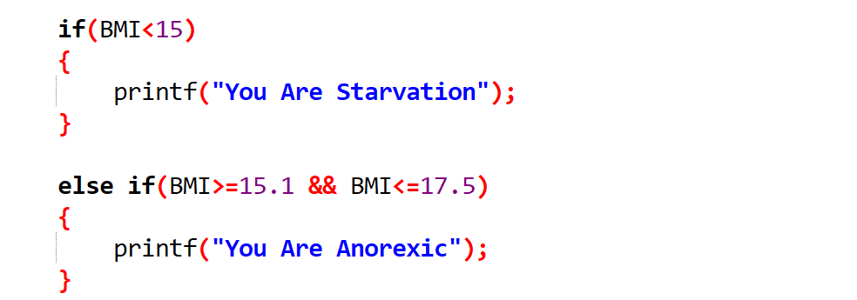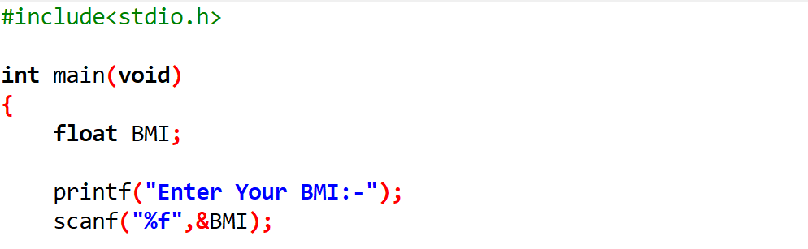

|  |  |
| --- | --- |
| BMI Category | BMI |
| Starvation | < 15 |
| Anorexic | 15.1 to 17.5 |
| Underweight | 17.6 to 18.5 |
| Ideal | 18.6 to 24.9 |
| Overweight | 25 to 25.9 |
| Obese | 30 to 30.9 |
| Morbidly Obese | >= 40 |

